
INDOOR BODYPILOTING
Rules, Laws &
Interpretations of the Game

Authored by Mason Corby | F.L. 2014
Version 1.0
bodypiloting.com

INTRODUCTION

BODYPILOTING — THE GAME
Follow-the-leader, dynamic flying (body piloting), is a type of flying that has been around for longer than this game. Using lines and zones, two individuals flying (dynamic follow-the-leader) can be judged and scored and, therefore, creating the game BodyPiloting.
The game consists of two individuals flying against one another, performing tricks and lines with precision and speed. One flyer leads for a pre-determined timed game whilst collecting points, and the other follows. After the first game, the flyers switch positions — follower becomes leader and leader becomes follower — and fly for another pre-determined timed game. This is classed as the first set. The flyer with the highest total of points after a defined number of sets wins the match.
The aim is not to destroy your opponent by performing continuous non-stop tricks, tricks and lines where the follower is not able to see them, or impossible lines and tricks to follow that suddenly stop in place and start again. The goal is to fly big, clean, and fast into the end zones, scoring points on lines as well as well-placed tricks, whilst maintaining speed.
The best flyer is not the one that can pull off the most tricks blind to the other, but the one that can out-fly and out-smart the other, whilst presenting all tricks and lines in full view of the other competitor.
GOVERNANCE & APPLICATION OF RULES

This document constitutes the official rules and governing framework for Indoor BodyPiloting under the BodyPiloting Competition (BPC) format.
These rules apply to all sanctioned matches, competitions, and events unless otherwise specified by the event organiser.

Purpose
The purpose of this document is to:
1. Standardise gameplay, scoring, and judging
2. Ensure fairness, safety, and consistency
3. Provide a scalable structure for national and international competition

Authority
In all cases:
1. The referee has final authority on matters of fact
2. Judges must apply rules in accordance with the Principles of Judging (Section 14)
3. Where interpretation is required, decisions must prioritise fairness, visibility, and competitive integrity

Referee Discretion
In exceptional circumstances, the referee may override standard scoring where:
1. A situation falls outside the defined rules
2. Safety is compromised
3. A clear and unfair advantage has been gained outside the intent of the game

All such decisions must align with the Principles of Judging (Section 14).

Official Language
In the event of interpretation discrepancies, the English version of this document shall take precedence.

Version: 1.0
This document is subject to ongoing refinement and future revisions.
INDEX

Section 1 — The Flying Chamber
Section 2 — Glossary
Section 3 — Reference Area (RA) — Shoes/Helmet
Section 4 — The Player and Player's Equipment
Section 5 — Mode of Play
Section 6 — Scoring System — Lines, Tricks, and Penalties
Section 7 — Time Keeping
Section 8 — Players' Misconduct
Section 9 — Duties of Referee and Zone Judges
Section 10 — Judging Method
Section 11 — Categories
Section 12 — Arena Markings & Dimension Guidelines
Section 13 — Index to the Laws
Section 14 — Principles of Judging
Section 15 — Competition Format
Section 16 — Global Ranking & Progression System
Section 17 — Digital Community & Platform
Section 18 — Ways to Play

SECTION 1
The Flying Chamber

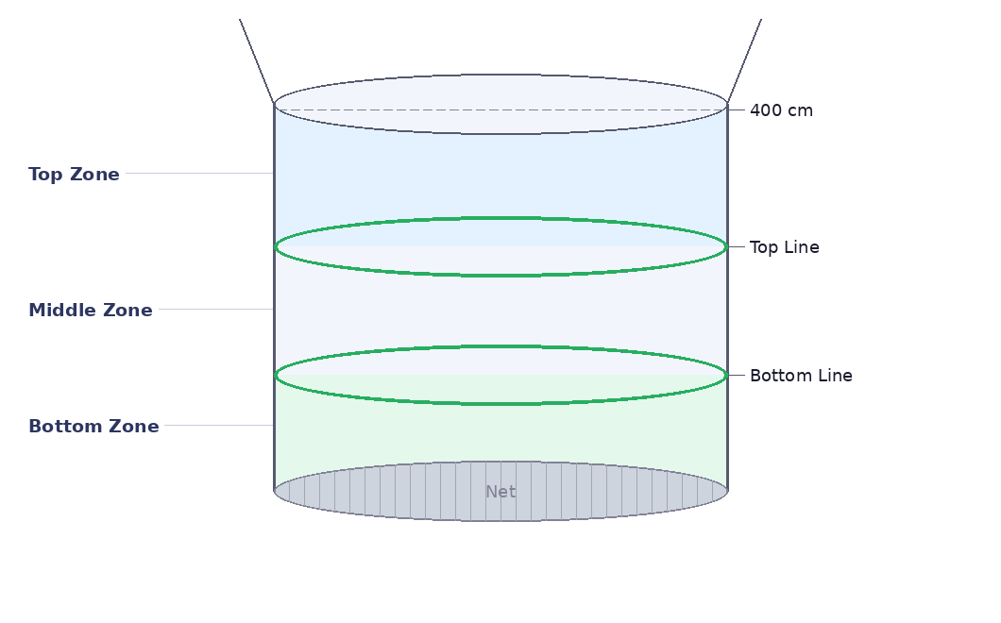
Figure 1 — The Flying Chamber showing Top Zone, Middle Zone, Bottom Zone, zone lines and Net

Notes
1. The bottom and top lines are part of the middle zone, and the diffuser is part of the top zone.

2. There is no penalty for hitting the net or going into the diffuser.

3. For all speed and skill categories of the game, the arena will be to the dimensions stipulated in Section 12.

4. The bottom and top lines must be clearly marked and visible to all flyers, judges, and spectators.

5. Dimensions for the different categories require the top line and bottom line to be adjusted.

6. The bottom and top zones are the scoring zones for lines and tricks; the middle zone is void for scoring lines — only trick scores can be earned in the middle zone.

7. The bottom and top zones will be referred to as end zones.

8. Lights may be used to define the lines; if no lights are available, coloured tape or a clearly defined line may be used.

9. The 400cm line is to be measured from the net and is not marked. It is used as a reference line for measuring the Top Line.

SECTION 2
Glossary

TERM | DEFINITION
180 | A change in heading of 180 degrees. (180 degrees is the increment by which all spins and tricks are measured — first the 180, then 360, then 540, etc.)
360 | A 360-degree rotation of the body returning to its original heading.
540 | A 540-degree rotation of the body rotating 180 degrees further than the 360.
720 | 2 continuous 360 rotations of the body returning to its original heading.
900 | 2½ continuous rotations of the body returning to the opposite heading.
AT THE TOP | Refers to a move performed at the top of the tunnel. E.g., head down 360 during a layout at the top section of the tunnel.
BACK FLYING | The ability to fly in the back-to-earth position in a controlled situation and manner, moving or static.
BACK SPIN | A controlled spin or turn whilst back flying.
BELLY FLYING | The ability to fly on the belly-to-earth position in a controlled situation and manner, moving or static.
BELLY SPIN | A controlled spin or turn whilst belly flying.
BODY | Refers to a flyer's own body of mass.
BOTTOM LOOP | A 180-degree rotation of the body around the latitude axis whilst flying toward the net. Feet passing under the body (head down) or head passing under the body (head up).
BLIND | A move or trick performed in a position or location where the other competitor cannot see it being performed.
BREAKER | A rotation around the longitudinal axis of the body whilst lying flat on the side, moving from one surface area to another. The legs must travel a further radius than the head.
BUST | When a flyer does not copy or follow the line or trick that the leader performs (see Section 6 for scoring).
BURBLING | When one flyer is directly under the other flyer, obstructing the clean airflow causing loss of air and instability.
CARTWHEEL | A sidewards rotation around the centre axis of the body.
CARVE | The flyer moving/travelling in a horizontal sideways motion around the tunnel.
CORK | To lose control of one's body and gain lift flying upward through the tunnel.
CONTACT | Bumping or touching another flyer with a part of the body.
COLLISION | The two flyers impact each other or the wall causing them to cork, temporarily stop flying, or become injured.
CUTTING | When the follower flies a shorter line than the leader. E.g., cutting the corner — not flying the same distance line.
DIFFUSER | The section of the tunnel that begins to widen after the flying chamber.
DOWNWARD MOTION | Flying towards the net.
MOVING | Moving throughout the tunnel. Not stopping. E.g., carving/layout.
END ZONE | The bottom and top zones at either end of the arena.
ENTRY | When a flyer enters the arena at the beginning of the round.
EXIT | When a flyer leaves the arena at the end of the round.
FLAT SPIN | Rotation of the body whilst flat (belly/back) on the latitude axis.
FLYER 1 | Lead flyer.
FLYER 2 | Following flyer.
FOLLOWER | The flyer who is in second place and following.
GAME | Refers to the rotation/timed block flown. Two games in a set, and four games — or two sets — in a match.
HEAD DOWN | Flyers in a head-down orientation: head towards the net, feet towards the diffuser.
HEAD UP | Flyers in head-up orientation: head towards the diffuser, feet towards the net.
INFACE | A flyer's head and front of body facing towards the centre of the tunnel.
LAYOUT | A flyer moves in a vertical up-and-downward motion from one side of the tunnel to the other.
LINE | The path a flyer chooses to travel throughout the tunnel whilst moving.
MATCH | Refers to the entire games played between two players. Four games and two sets (two games per set) per match.
NET | The wire interlace at the bottom of the flight chamber.
NET STRIKE | Hitting the net with a part of the body.
OBSTRUCTION | Blocking a flyer from continuing on their intended path.
OUTFACE | Facing outwards towards the glass in a head-down or head-up orientation. Back facing towards the centre of the tunnel.
PENALTY | A flyer receives 1 point against them; hence, a point is awarded to the opposing flyer.
REFERENCE AREA (RA) | The helmet or shoes — the reference point used to judge whether a flyer passes into a zone or not.
REPEATED ACTION | The same behaviour occurring three (3) or more times within a single game. Applies to blind tricks, stopping during movement, and uncompleted tricks (see Section 6).
SET | Refers to the 2 x timed blocks/games flown.
SIDE FLYING | Carving whilst orientated on the side of the body.
STABLE | Flying still with no involuntary movements.
STATIC | Not moving through the arena; stationary.
SWITCHING LEADS | Changing the positions of the flyers. Leader becomes follower, follower becomes leader.
SWITCH DIRECTIONS | Changing the direction of the path flown. E.g., inface carve left to inface carve right.
UPWARD MOTION | Moving in an upward motion towards the diffuser away from the net.
WALL STRIKE | Hitting/touching the wall with part of the body.
ZONES | The sections of space between the net and bottom line, the bottom line and top line, the top line and diffuser, and above the diffuser.

SECTION 3
Reference Area (RA) — Shoes/Helmet

1. | Reference Area | The shoes and helmet are used as references to determine whether a flyer has entered a zone, touched a line, or is out of bounds.

 | a) | When the flyer is in the head-down orientation, the reference area is the helmet. When the flyer is in the head-up orientation, the reference area will be the shoes. The helmet and shoes will be referred to as the reference areas (RA).
 | b) | When a flyer is performing a layout, the RA is measured off the orientation on which the lead flyer enters the zone first.

2. | Shape & Construction | The helmet and shoes must be clearly visible in comparison to the rest of the body. The helmet must be made of carbon fibre or hard plastic and must be a full-face helmet. The shoes must be of material with no polished leather and no steel caps. Nothing shall be used in their construction that would be harmful to the players or the glass.

3. | Loss of Reference Area | If a flyer loses a reference area the game is paused and the item retrieved. Once retrieved the game continues as normal. If the reference area is destroyed, a replacement must be found and the game continues. If the loss of a reference area is due to negligence, the flyer responsible will be penalised or risk disqualification.

SECTION 4
The Player and Player's Equipment

1. | Number of Players | There are two players per match. One player leads for the first game and the other follows. At the beginning of the second game the players switch leader and follower. Number one becomes number two and number two becomes number one.

2. | Ranking | A competitor must not fly in a division at a rank they have not earned unless approved by the referee. Once a competitor competes as an orange buff in 90%, they must always compete as an orange buff 90% or higher (see Sections 11–12 for more details).

Players' Equipment
 | a) | A player must not wear anything that might prove dangerous to other competitors.
 | b) | A player's normal gear must consist of a suit of distinctive colour and/or pattern, an approved helmet easily distinguishable from the suit, shoes that can be easily distinguished from the suit, and a pair of gloves. A buff may be worn to help define the suit from the helmet but is not required.
 | c) | Protective clothing may be worn provided it contains nothing of a rigid or dangerous nature.
 | d) | The referee must order a player to remove any part of their equipment which is considered dangerous and must not allow the player to take any further part in the game until the order is obeyed.
 | e) | The colours of the suits and RA worn by the players must be easily distinguishable. If, in the opinion of the referee, similarity between the equipment might affect the proper conduct of the game, the referee must order either player to change equipment.

SECTION 5
Mode of Play

1. | Objective | The objective of the game is to fly as clean and fast as possible whilst performing strategically placed lines and tricks to out-fly and bust your opponent, scoring more points than them over a match.

2. | Start of Play | The two flyers toss a coin to decide the starting positions. The winning toss decides who leads and who follows. The losing toss takes the other of the alternatives.

3. | Mode of Play | Once the lead flyer enters the tunnel they can perform tricks or fly lines into one of or both end zones to collect points from the follower, providing the line or trick does not stop moving and is not performed blind to the follower (see Section 6 for scoring).

4. | Cutting | If the following flyer is cutting on the first pass there is no penalty, although if the follower impacts the leader by cutting, resulting in a dangerous action or collision, the referee must award a penalty to the follower (see Section 8).

5. | Obstruction / Burbling | A player that burbles another flyer will only receive a penalty if it is conducted in a dangerous manner, resulting in a possible collision or injury (see Section 8).

6. | Contact | Contact is allowed in the form of bumping another flyer with the entire body/shoulder. If contact is made with the use of the hands or feet in the form of punching, kicking, pushing, pulling, or pinching, the offending player will be awarded a penalty and will be subject to disqualification (see Section 8).

SECTION 6
Scoring System — Lines, Tricks, and Penalties

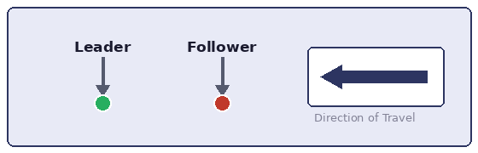
Figure 2 — Leader (green), Follower (red) and direction of travel key

Diagram Interpretation Guide
Green — Leader
Red — Follower
Dot — Reference Area (RA)
Arrow — Direction of movement
✔ — Correct execution — scored
✖ — Incorrect execution / bust

1. | Value | Only the lead flyer can gain points for busts. A point will only be awarded to the follower in the case of the leader receiving a penalty.
 | a) | A line bust will count for 1 point.
 | b) | A trick bust will count for 1 point.
 | c) | A penalty will count for 1 point awarded to the opposing flyer.

2. | Deciding Winners | The game will be decided by the flyer who has accumulated the most points over the defined match period. If both flyers score the same amount of points, the tie-break procedure below applies.

Tie-Break Procedure
If both flyers finish with equal points, the winner will be determined in the following order:
1. Highest number of clean scoring actions (non-penalised)
2. Lowest number of penalties received
3. Majority decision from judges based on overall performance
4. If still tied: a 1-minute sudden-death fly-off will be conducted

3. | Line Busts | The lead flyer can be awarded points for flying lines into end zones whilst leading the follower. To score points, the lead flyer must fly their relevant reference area (RA) fully into the required zone (bottom or top zones) and the follower must fail to do so. The middle zone is void for lines, but not for tricks.

 | a) | A flyer must completely pass a line with an RA into an end zone to be classed as in the scoring zone. No part of the flyer's RA is to be touching a line. If part of the flyer's RA is touching the bottom or top line it will be classed as in the middle zone; if they enter the diffuser it will be classed as the top zone.

Top Zone — In / Out of Scoring Zone
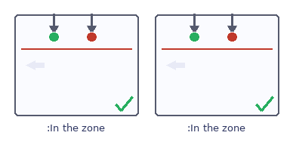  ✓ In the zone | 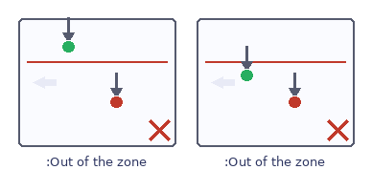  ✗ Out of the zone

Bottom Zone — In / Out of Scoring Zone
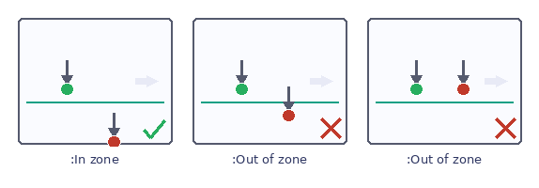

 | b) | If the leader enters an end zone and the follower does not enter the same zone with the same RA or in the same orientation, the leader is awarded a point.

1 Point Awarded to Leader
Top zone — following flyer does not clear line into zone:
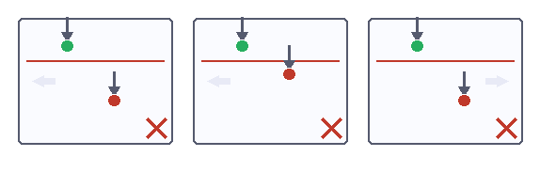
Bottom zone — following flyer does not clear line into zone:
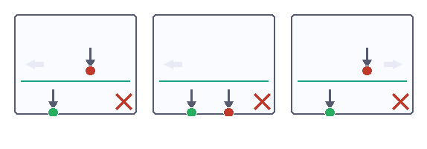

 | c) | If the follower enters the same end zone in the same orientation with the same RA, no point is awarded.

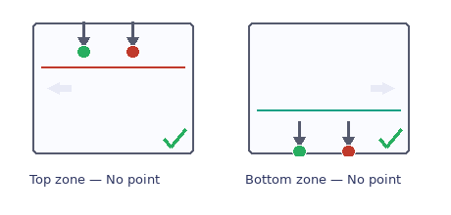
Figure 3 — Follower copies leader in both top and bottom zones — no point awarded

 | d) | If the lead flyer does not enter the top or bottom zone, the follower may enter any zone with no points being awarded.

Top zone — no points as leader does not enter the top zone:
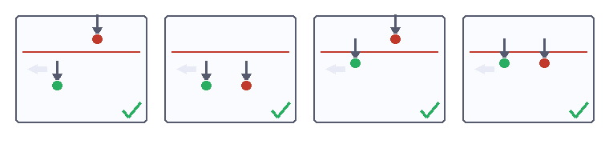
Bottom zone — no points as leader does not enter the bottom zone:
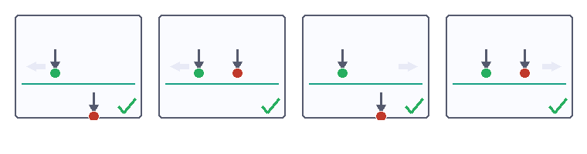

5. | Tricks / Lines | If the leader performs a trick or unique line, the follower must sufficiently replicate the leader's movement. A bust will be awarded if replication is inadequate.

Replication Requirements
Replication requires:
1. Matching the same movement type (line or trick)
2. Matching the same rotational axis
3. Matching the same direction of movement
4. Maintaining comparable path, timing, and intent

A bust will be awarded if the follower:
1. Performs a different movement
2. Alters direction or axis
3. Shortens or modifies the line to gain advantage
4. Fails to complete the movement

6. | Trick Count | A trick may only be scored off twice per side per timed game. E.g., half breaker left twice, and half breaker right twice. If a trick is performed and scored from twice, no point will be awarded to the leader if the trick is performed again and the trick/line is not followed.

7. | Blind Line / Trick | A blind line/trick will not receive a penalty unless it constitutes a repeated action (three or more times within a single game). If a follower still attempts to match the line or trick it is now classed as seen and if not followed perfectly will be classed as a bust.

Definition — Repeated Actions
A repeated action is defined as the same behaviour occurring three (3) or more times within a single game.
This applies to:
1. Blind tricks
2. Stopping during movement
3. Uncompleted tricks

8. | Unrecognisable Tricks / Lines | A trick or line will be considered unrecognisable if:

1. The movement is not clearly identifiable as a defined trick or line
2. The movement is not completed in a continuous and controlled manner
3. The movement lacks sufficient clarity for the follower to reasonably interpret and replicate

In such cases:
1. No point will be awarded to the leader
2. No penalty will be applied unless safety is compromised

9. | Penalties / Busts | Penalties will be awarded by the referee to any flyer for unsafe flying or conduct, stopping three or more times through a trick/transition/line, uncompleted moves occurring three or more times, corking, collisions, or blind lines/tricks.
 | a) | In the result of a penalty, a point will be awarded to the non-offending flyer.

10. | Disqualification | A flyer will be disqualified and all awards and points for that division and game will be null and void if:
 | a) | The offending competitor repeatedly performs dangerous practices resulting in a collision from unsafe flying or from causing injury to another competitor.
 | b) | A flyer is deemed to be flying in a category for which they do not yet have the required skill.

11. | Injury | If a flyer is injured, the time is paused and:
 | c) | If the flyer is able to continue, both flyers start from the door in the same positions as when the incident occurred. The time is continued from when it was first paused.
 | d) | If the flyer is unable to continue due to an injury caused by the other flyer, that flyer will be disqualified.
 | e) | If the flyer is unable to continue due to self-injury, the winner will be awarded to the opposing flyer.

12. | Entry | On entry, the leader is allowed to perform any line/trick desired, and the follower must copy. If the follower does not complete the same entry, a bust will be awarded, and the leader will gain a point.

13. | Exit | The leader can choose to exit the tunnel any way desired in accordance with Section 6, paragraph 5. The follower must follow the exact line out the door as the leader; if not then the leader is awarded one point.

14. | Simultaneous Error Resolution | If both players fail to correctly execute a movement within the same sequence:

1. No point is awarded — play continues
2. If one player gains a clear competitive advantage through incorrect execution, the referee may award or deny a point based on the Principles of Fairness (Section 14)

SECTION 7
Time Keeping

1. | Length of Match | Matches are recommended for 4 x 2-minute sets for open categories and 2 x 1:30-minute sets for all other categories. If more or less time is desired, keep to even numbers so entries and exits are even.

2. | Interval | There must be a one-minute minimum interval for a break between sets.

3. | Entry | Before the start of each set both flyers must stand in the door and confirm readiness with the referee before beginning. The referee then gives the flyers the OK to start. The timer starts when the leader's shoe leaves the door and enters the arena.

4. | Changing Leads | Once the first game has finished, a flasher will begin for a duration of 3 seconds. At this time, the flyers switch positions (leader and follower). When the flashing stops, the flyers continue with the 2nd game of the set.

5. | End of Game | In the last 5 seconds of the set a flasher will begin to signal the end of the set and for the flyers to leave the arena. At the end of the game the flasher and timer will stop. The leader must have completely exited the flying arena or will be awarded a time penalty. If the follower does not exit the tunnel within a 3-second period after the timer has stopped they will also be awarded a penalty.

Note
A timekeeper may be employed to signal half time and full time, in which case the referee on receiving the timekeeper's signal must perform the required actions.

SECTION 8
Players' Misconduct

1. | Definition | A player is guilty of misconduct and will receive a penalty if they:
 | a) | Pull, push, pinch, kick, or strike the other competitor.
 | b) | Effect the burble of the other flyer causing them to cork out into the diffuser.
 | c) | Perform a risky move with negligence to safety, causing a possible collision or harm to the other flyer.
 | d) | Conduct a dangerous action resulting in injury or possibility of injury to another flyer.
 | e) | Perform dangerous practices resulting in a collision from unsafe flying or from causing an injury to another competitor.
 | f) | Engage in unsafe flying or conduct, including stopping through a trick/transition/line, uncompleted moves, corking, collisions, or blind lines/tricks.
 | g) | Obstruct the other flyer blocking their clean path to follow, resulting in a collision or possible injury.

SECTION 9
Duties of Referee and Zone Judges

1. | Appointment | In all games one referee and two zone judges must be appointed or mutually agreed upon by all contestants. The referee must be a flyer of equal or higher skill level as those competing; the zone judges must be trained in judging for their line.

2. | Enforce Laws | The referee must enforce the laws of the game and will impose penalties for any deliberate breach of the laws.

3. | Time Keeper | The referee will be the sole time keeper unless the duty has been delegated to another person.

4. | Power to Stop the Game | The referee may, at their discretion, temporarily suspend or prematurely terminate a match because of misbehaviour of players, dangerous actions, loss of gear, or interference from spectators. At this point, the doorman must signal for the players to stop.

5. | Change of Decision | The referee judges on matters of fact and must not subsequently alter those judgements.

6. | Accept Zone Judges' Decision | The referee must accept the decision of a zone judge relating to line busts.

7. | Zone Judge Position | Each zone judge must remain on the subsequent line they are judging. One judge for the top line. One judge for the bottom line.

8. | Zone Judge Advisory | Each zone judge may advise the referee of a bust that they feel has not been noticed.

9. | Indicating Line Bust | End zone busts will be indicated and scored by the zone judges.

10. | Indicating a Trick Bust | Tricks and moving line busts will be indicated by the referee.

11. | Indicating a Penalty | Penalties will be indicated by the referee.

SECTION 10
Judging Method

1. | Lines | Lights will be used to mark the lines that define the zones. The bottom and top lines will be blue and the out-of-bounds line will be green. The lights must always stay the same colour and must not change. If no lights are available, tape must be used.

2. | Zone Busts | Zone busts will be judged by two zone judges: one viewing the top line and one viewing the bottom line. Each judge must look at the line closest to their side and line it up with the opposing side. Judges must determine whether the leaders' and followers' RA fully passes the line entering into one of the scoring zones.

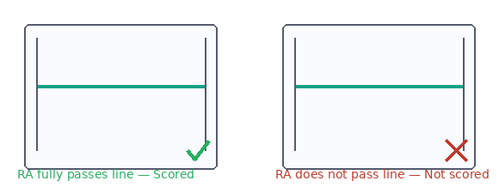
Figure 4 — Judge's view: RA fully passes line (scored ✓) vs. RA does not pass line (not scored ✗)

3. | Trick / Line Busts | The referee will judge trick and line busts from a view that allows them to see the entire arena. Their judgement is final.

4. | Penalties | The referee will judge penalties from a view that allows them to see the entire arena. Their judgement is final.

SECTION 11
Categories

1. | Categories | For safety and ease of learning, the game has been broken down into 8 speed categories (low to high speed) and 7 skill/colour categories. The lowest speed class does not necessarily mean the lowest skill level. Each speed class has different levels/skill categories. Holding a 'Blue' skill level in speed class 95% does not necessarily mean you will hold it in another speed class.

2. Ranking Chart
 | a) | The table on the following page explains the classes, colour/skill categories, and the dimensions needed to mark the arena. Use this along with Section 12, paragraph 5 to understand how to mark the arena.
 | b) | Low speed starts from the bottom of the table and works upwards (60%–95%). The beginner skill level starts from the left and works to the right (White Buff – Grey Buff). The category you are in is defined by what kind of tricks/moves and lines you are able to complete. If you can complete all moves in the Orange Buff 85%, you are allowed to perform all moves/tricks/lines defined in the lower categories (White, Yellow, and Blue 85%), but are restricted from performing any moves listed above this level (Green, Red, and Grey 85%).

The Grading
1. There is a defined list of skills and tricks set out across 7 levels, tiered to 8 wind speeds. (Note: speeds will vary at different tunnels.)
2. The skills and tricks change levels across each wind speed set based on complexity of that skill or trick being performed at that speed range.
3. A flyer will progress within each wind speed category from White to Grey. It is unlikely a flyer will be the same level in all speed categories.
4. A flyer is considered at a certain colour for each wind speed when they can competently complete all lines and tricks listed in that category (and below).
5. Each skill or trick has a unique number, and there is a corresponding video demo for each.
6. A flyer's self-assessment tool has also been provided.

The Dimensions
1. Speeds are based on average percentage of ISG wind-tunnel design.
2. Top line is measured from 400cm from the net.
3. Bottom line is measured from the net.

3. | Progression | To progress through each skill category you must complete the required skill sets. It is not necessary to start from the lowest speed class. However, if a flyer wishes to move between classes it is recommended that they go through the progression again.

4. | Multiple Buffs and Categories | It is possible to hold multiple buffs in multiple categories.

5. | Competing | If a flyer wishes to compete, they are allowed to compete against another flyer ranked within 1 buff of them. E.g., a Blue Buff can compete with an Orange or a Yellow Buff. To compete against another flyer in a different speed category, both flyers must agree, and competition may only occur within 1 speed category and the same colour buff. E.g., Blue Buff 85% can only compete with Blue Buff 80% or 90%, not an Orange 90%.

6. | Arena Changes | The dimensions of the arena will change due to the category being flown (see Section 12).

Ranking Chart — Arena Dimensions by Category
The table below shows the top-line and bottom-line dimensions (measured from the net) for each colour level and speed class combination.

Speed | White | Yellow | Blue | Orange | Green | Red | Grey
95% | T:110 B:110 | T:110 B:110 | T:110 B:110 | T:110 B:110 | T:100 B:88 | T:100 B:88 | T:88 B:88
90% | T:110 B:110 | T:110 B:110 | T:110 B:110 | T:110 B:110 | T:100 B:88 | T:100 B:88 | T:88 B:88
85% | T:110 B:110 | T:110 B:110 | T:110 B:110 | T:110 B:110 | T:100 B:88 | T:100 B:88 | T:88 B:88
80% | T:110 B:110 | T:110 B:110 | T:110 B:110 | T:110 B:110 | T:100 B:88 | T:100 B:88 | T:88 B:88
75% | T:110 B:110 | T:110 B:110 | T:110 B:110 | T:110 B:110 | T:100 B:88 | T:100 B:88 | T:88 B:88
70% | T:120 B:88 | T:120 B:88 | T:120 B:88 | T:110 B:110 | T:100 B:88 | T:100 B:88 | T:88 B:88
65% | T:120 B:88 | T:120 B:88 | T:120 B:88 | T:110 B:110 | T:100 B:88 | T:100 B:88 | T:88 B:88
60% | T:120 B:88 | T:120 B:88 | T:120 B:88 | T:110 B:110 | T:100 B:88 | T:100 B:88 | T:88 B:88

SECTION 12
Arena Markings & Dimension Guidelines

1. | Introduction | These guidelines set out the official markings and dimensions of the playing arena for body piloting matches. All arenas can be adjusted for the different speed categories.

2. | Categories | Various categories require a different placement of the lines. All markings and lines must be measured from the net according to the dimensions stipulated in paragraph 5 below.

3. | Markings | Each arena must have the following two lines marked:
 | a) | Bottom line
 | b) | Top line

4. | Diagram | The diagram below illustrates the lines and markings referred to above.

Figure 5 — The Flying Chamber showing zone lines, Top Line, Bottom Line and Net

5. | Dimensions | Below are the arena dimensions for all levels of flying. Use the graph in Section 11 to determine the correct dimensions needed.

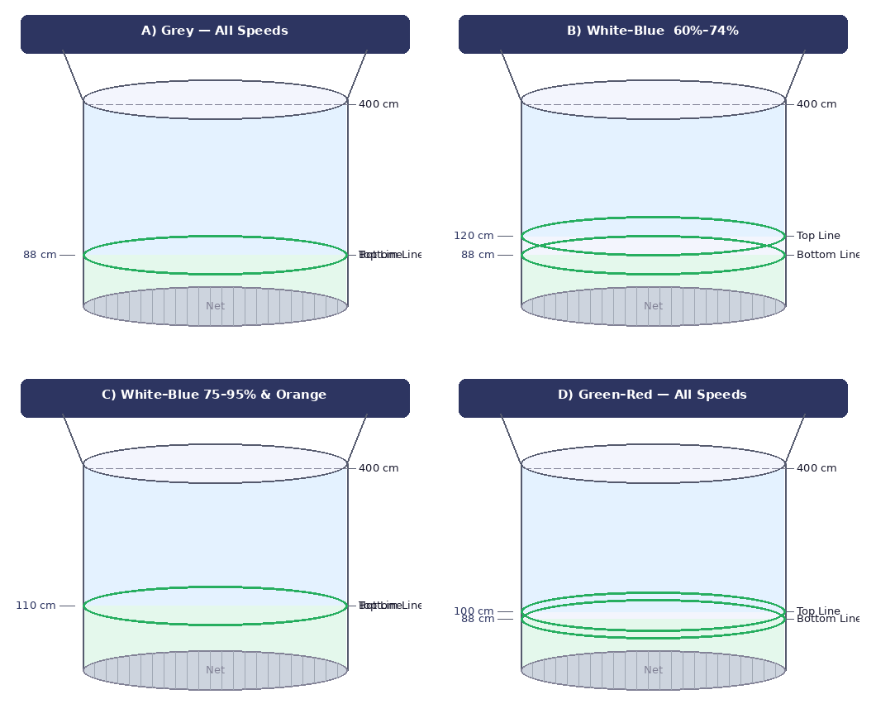
Figure 6 — Arena configurations A (Grey), B (White–Blue 60–74%), C (White–Blue 75–95% & Orange), D (Green–Red)

Configuration | Top Line (from net) | Bottom Line (from net)
A — Grey, All Speeds | 88 cm | 88 cm
B — White–Blue, 60%–74% | 120 cm | 88 cm
C — White–Blue 75–95% & Orange, All Speeds | 110 cm | 110 cm
D — Green–Red, All Speeds | 100 cm | 88 cm

NOTE: The 400cm line is measured from the net. This is not necessarily where the diffuser is.

SECTION 13
Index to the Laws

TERM | REFERENCE
Bumps and Strikes | Section 8, Para 1(a)
Burbling | Section 8, Para 1(b) | Section 5, Para 5
Contacting | Section 5, Para 6
Cutting | Section 5, Para 4
Causing Injury | Section 6, Para 7–8
Endangering Another Flyer | Section 8, Para 1(c)
Unsafe Flying | Section 8, Para 1(f)
Bust | Glossary
Obstructing | Section 5, Para 5
Blind / Dangerous Lines and Tricks | Section 6, Para 6
Repeated Actions | Section 6, Para 6–7 | Glossary
Tie-Break Procedure | Section 6, Para 2
Unrecognisable Trick / Line | Section 6, Para 8
Referee Discretion / Override | Governance — Referee Discretion

SECTION 14
Principles of Judging

Judging decisions must be based on the following principles. These principles apply to all referees and zone judges across all sanctioned events.

1. Replication Accuracy
The follower must replicate:
1. The same line or trick
2. The same orientation
3. The same direction
4. Comparable timing and execution

Failure to do so results in a bust.

2. Visibility
All movements must be clearly visible to the opposing flyer. Judges must consider:
1. Whether the follower had a fair opportunity to see the movement
2. Whether the leader intentionally reduced visibility

3. Continuity of Movement
All movement must be continuous, controlled, and intentional. Repeated stopping or segmented movement will result in:
1. No score awarded
2. A penalty if the behaviour is excessive or constitutes a repeated action

4. Control & Stability
Movements must demonstrate stability, body control, and intentional execution. Loss of control (e.g. corking) will result in a penalty.

5. Competitive Fairness
Judges must ensure:
1. The leader is attempting to out-fly fairly
2. The follower is making a genuine attempt to match
3. Unfair exploitation of rules must not be rewarded

6. Acceptable Deviation
Replication does not require perfect mirroring. Judges must allow for:
1. Minor positional variation
2. Natural body differences between competitors
3. Environmental factors within the tunnel

A bust is only awarded where:
1. A competitive advantage is gained through the deviation
2. The movement is clearly and materially altered from the leader's execution

SECTION 15
Competition Format

1. | Match Structure | A match consists of 2 sets. Each set contains 2 games. Players must alternate leader and follower roles within each set.

2. | Tournament Formats | Events may be conducted in a variety of formats depending on the size and nature of the competition:
 | a) | Head-to-head elimination
 | b) | Round robin
 | c) | Ladder or ranking system

3. | Seeding | Competitors may be seeded based on:
 | a) | Current ranking
 | b) | Previous results
 | c) | Event organiser discretion

4. | Progression | Competitors progress based on:
 | a) | Match wins
 | b) | Points accumulation
 | c) | Tournament structure as defined by the event organiser

Event Organisers
Event organisers may adapt the competition format to suit the scale and context of their event, provided the core match structure (Section 6 scoring, Section 7 time keeping, and Section 14 judging principles) is maintained.

SECTION 16
Global Ranking & Progression System

16.1 Purpose
The BodyPiloting Ranking System establishes a structured global progression pathway for all pilots, enabling:
1. Clear skill progression
2. Local and international competition alignment
3. Ongoing engagement outside of major events
4. Integration with the official BodyPiloting digital platform

16.2 System Overview
The ranking system consists of three interconnected layers:

Layer 1 — Skill Level (Buff System)
Already existing — White → Grey, based on ability to complete defined skills (see Section 11).

Layer 2 — Rank Tier (Competitive Status)
Earned through sanctioned matches. Represents competitive standing within the global system.

Layer 3 — Title Level (Hierarchy System)
Progresses from Local Champion through Regional, National, World, and Grandmaster.

16.3 Rank Tier System
All competitors are assigned a Rank Tier based on performance in sanctioned matches. Tiers are ordered from entry level to elite:

TIER | STATUS
Unranked | Entry status for all new competitors. No ranking impact on match results.
Bronze | First competitive tier. Earned through wins in verified local matches.
Silver | Intermediate tier. Demonstrates consistent competitive performance.
Gold | Advanced tier. Strong record across multiple sanctioned matches.
Elite | High-level tier. Competitive performance at regional or national level.
Master | Highest rank tier. Reserved for top-tier competitors with elite records.

Rank Progression Rules:

Points are earned through:
1. Match wins
2. Tournament placements
3. Verified local matches

Points are lost through:
1. Match losses
2. Inactivity (rank decay — see Section 16.7)

Rank thresholds are defined and maintained within the official BodyPiloting digital platform (see Section 17).

16.4 Title Progression System
The Title System provides a structured championship hierarchy from local gym-level competition through to global recognition:

LEVEL | TITLE / PATHWAY
Local | Local Events / Gyms → Local Champion
Regional | Regional Competition → Regional Champion
National | National Competition → National Champion
International | World Ranked → World Champion
Final Tier | Grandmaster — the pinnacle of the BodyPiloting hierarchy

Title Rules:
1. Titles are earned by winning designated events or by defeating the current title holder in an official Title Match
2. Titles must be defended within a defined period as specified by the platform
3. Failure to defend: the title becomes vacant or is reassigned via event

16.5 Challenge System
Players may issue challenges under the following rules:

Challenge Eligibility
A challenge must be within:
1. 1 Rank Tier of the challenged competitor
2. OR the same Title Level

Challenge Formats
Challenges may occur:
1. Locally — at any participating gym or facility
2. At events — during sanctioned competitions
3. Through official platform matchmaking (see Section 17)

Approval & Recording
Approved challenges become officially ranked matches and are recorded in the platform system.

16.6 Match Types
All matches are classified under one of the following types:

TYPE | EFFECT
Casual | No ranking impact. No record required. For practice and development only.
Ranked | Affects Rank Tier. Must be logged and verified via the platform.
Title Match | Affects Titles and Championships. Requires official sanctioning and judging panel.

16.7 Activity Requirement
To maintain ranking status, competitors must remain active within the system:
1. Players must compete within a defined period as published on the official platform
2. Inactivity results in rank decay — progressive reduction in rank points
3. Prolonged inactivity results in title forfeiture where applicable

16.8 Digital Platform Integration
All rankings, titles, and match results are managed through the official BodyPiloting platform (see Section 17). The platform is the authoritative record for:
1. Player profiles
2. Match history
3. Ranking progression
4. Title tracking
5. Community interaction

SECTION 17
Digital Community & Platform

17.1 Purpose
The official BodyPiloting platform functions as the central hub for all competition, progression, and community activity. It connects pilots globally and provides the infrastructure for the ranking and title systems defined in Section 16.

Platform Functions
1. Competition — match recording, challenge management, ranked events
2. Progression — rank tracking, title history, skill buff records
3. Community — content sharing, pilot interaction, footage archive

17.2 Player Profiles
Each registered player has an official profile containing:
1. Rank Tier
2. Skill Buff Level
3. Match history
4. Titles held
5. Media — videos and photos

17.3 Community Features
Players may use the platform to:
1. Post content and share flights
2. Upload competition footage
3. Follow other pilots
4. Engage with the wider BodyPiloting community

17.4 Match Recording
All official matches must be logged, verified, and stored within the platform. This ensures:
1. Transparency — all results are publicly accessible
2. Ranking accuracy — points adjustments are based on verified results only
3. Historical tracking — permanent record of all sanctioned matches

17.5 Verification System
Matches are verified through one or more of the following:
1. Judges present at the match
2. Event organisers
3. Approved platform officials

Note
Unverified matches will be recorded as Casual and will carry no ranking impact until verification is completed. Match footage submitted for verification must clearly show both competitors, the referee, and all scoring zones.

SECTION 18
Ways to Play

BodyPiloting can be played and ranked through four official formats. Each pathway feeds into the global ranking system (Section 16) and provides distinct opportunities for skill development, local competition, and progression to national and world level.

Method 1 — Open Challenge (Street Match)

Players may challenge any other pilot at any time and in any location — at a tunnel, training session, or designated event. This is the core grassroots format of the game: fast, spontaneous, and competitive.

How It Works
1. A pilot may challenge any other pilot at a participating facility
2. Both pilots must be within 1 Rank Tier of each other (see Section 16.5)
3. If accepted, the match is played under standard rules (Sections 5–7)
4. Verified results are submitted to the platform and affect Rank Tier

The Gym / Tunnel Boss System
Each participating tunnel has a designated Gym Boss — the highest-ranked active pilot at that facility. To earn Local Champion status, a pilot must:
1. Accumulate sufficient wins within the local challenge system
2. Challenge and defeat the current Gym Boss in a sanctioned Title Match

Once the Local Champion title is held, the pilot may progress to Regional and National challenges through the Title Progression System (Section 16.4).

Method 2 — Tunnel Training Nights

Participating tunnels may host regular structured training nights providing a regular, low-barrier entry point into ranked competition. Training nights combine skill development with official match opportunities.

Format
1. The tunnel schedules a regular training night session open to all registered BodyPiloting pilots
2. Participants may issue Open Challenges (Method 1) during the session
3. Matches are played under standard rules and can be submitted as Ranked Matches
4. A referee or approved official must be present for matches to be ranked

Ranking Benefit
Training night ranked matches carry full ranking weight. Regular participation in training nights is one of the primary pathways for new pilots to build rank points and progress toward their first Gym Boss challenge.

Method 3 — Tunnel-Hosted Competition

Individual tunnels may host their own local competitions in either Round Robin or Knockout format. These events are fully sanctioned, carry ranking weight, and serve as a direct pathway to regional and national competition.

Round Robin Format
 | a) | All entered pilots compete against each other
 | b) | Winners are determined by total points accumulated across all matches
 | c) | Final standings affect Rank Tier of all participants

Knockout Tournament Format
 | a) | A qualifying round must be completed before the knockout bracket begins
 | b) | Qualifying round losers may be eliminated or enter a lower bracket at the organiser's discretion
 | c) | Knockout bracket follows standard match rules — loser is eliminated each round
 | d) | Winner earns maximum ranking points for that event tier

Qualifying Round — Official Format
The qualifying round is used to seed or filter pilots before the main knockout bracket. Format:
1. Each pilot is given 30 seconds of solo flight time
2. The objective is to fly over the Top Line and under the Bottom Line as many times as possible within the 30 seconds
3. Each successful crossing of both lines (top and bottom) counts as 1 point
4. The crossing must be fully completed — Reference Area (RA) must fully clear each line per the rules in Section 6
5. Pilots are seeded into the bracket from highest to lowest qualifying score
6. In the event of a tied qualifying score, a sudden-death 15-second extension is flown

Method 4 — State, National & World Tournaments

The highest level of BodyPiloting competition is the official multi-level championship circuit, structured across State, National, and World tiers. These events are hosted at designated tunnels and carry the greatest ranking weight in the system.

Tournament Structure
1. Events are hosted at designated facilities approved by BPC
2. Format is either Knockout (with qualifying round per Method 3) or Round Robin at the organiser's discretion
3. Entry is open to pilots who meet the minimum Rank Tier requirement for that event tier

Progression & Relegation

OUTCOME | CONSEQUENCE
Winner / Top Ranked | Awarded Title for that event tier. Progresses to the next level (e.g. State → National → World). Maximum rank points awarded.
High Finisher | Significant rank point gain. May qualify for the next tier event depending on available spots and organiser rules.
Mid Finisher | Standard rank points adjustment. Remains at current tier.
Low Finisher / Bottom Ranked | Rank point reduction. Lower-ranked pilots may be relegated to a lower category tier for subsequent events.

Progression Pathway — Overview
The four methods connect to form a continuous progression pipeline:

Open Challenges & Training Nights (Methods 1 & 2)
↓
Tunnel-Hosted Competition (Method 3) — Local Champion / Gym Boss
↓
State Tournament (Method 4) — State Champion
↓
National Tournament (Method 4) — National Champion
↓
World Tournament (Method 4) — World Champion / Grandmaster

